Indonesia Calls on the US to Join in Maintaining Peace and Stability in the Indo-Pacific Region

Jakarta, 14 July 2023 - The Minister for Foreign Affairs of Indonesia has called on the United States to join in maintaining peace, stability, and prosperity in the Indo-Pacific region. This was conveyed by Foreign Minister Retno as co-chair of the ASEAN-US Post-Ministerial Conference with the US Secretary of State on Friday (14/7).

Foreign Minister Retno stated that this year ASEAN will start mainstreaming the implementation of the ASEAN Outlook on the Indo-Pacific (AOIP) with all partners, including the US. Strategic approaches and habit of dialogue must always be upheld by ASEAN and the US.

"We believe that the US would continue to support ASEAN centrality and reinforce ASEAN’s position as epicentrum of growth. Collaboration is the only compass towards an inclusive regional architecture," said the Foreign Minister in her opening remarks.

The Foreign Minister stated that ASEAN is open to all countries that wish to enhance their interaction with the Indo-Pacific region. This is why the AOIP was created as a joint effort to promote concrete cooperation that benefits the people in four priority areas: maritime, connectivity, SDGs, and the economy. These areas of cooperation are similar to those in the ASEAN-US Comprehensive Strategic Partnership.

"Four areas that embody our shared interests and bring us together, rather than driving us apart. Four areas that would not only strengthen our bonds in the Indo-Pacific, but also to enhance trust and confidence among us. US support in implementing this Outlook is therefore very crucial," said Foreign Minister Retno.

The Foreign Minister emphasized that peace, stability, and prosperity in the Indo-Pacific are not only the interests of the region but also the world. As a comprehensive strategic partner of ASEAN, the US plays a crucial role in realizing this.

"ASEAN really needs the US to become a significant net contributor to the IndoPacific," the Foreign Minister affirmed.

At the meeting, ASEAN member states appreciated the US commitment to enhancing concrete cooperation under the ASEAN-US Comprehensive Strategic Partnership, including support for the implementation of the AOIP.

The meeting emphasized the need to intensify economic cooperation through increased business interactions, capacity-building for SMEs, infrastructure development for connectivity, and digital technology cooperation. The importance of cooperation in the areas of climate change and energy transition, including the development of the electric vehicle ecosystem, was also discussed.

Regarding regional issues, the US Secretary of State affirmed support for the centrality of ASEAN in maintaining peace, stability, and prosperity in the region. ASEAN member states invited the US to accede to the SEANWFZ Treaty Protocol to create a nuclear-free zone.

The meeting adopted the Annex to the Plan of Action of the ASEAN-US (2021-2025), which contains new cooperation commitments to implement the Comprehensive Strategic Partnership. The focus of cooperation includes maritime, economic, connectivity, and SDGs. The meeting also agreed to establish the ASEAN-US Center to be adopted at the ASEAN-US Summit in Jakarta in September 2023.

Indonesia currently serves as the coordinator of relations between the US and ASEAN.

***

For further information, please contact the following:

Director for Information and Media of the Ministry of Foreign Affairs - Hartyo Harkomoyo (+62811831899)

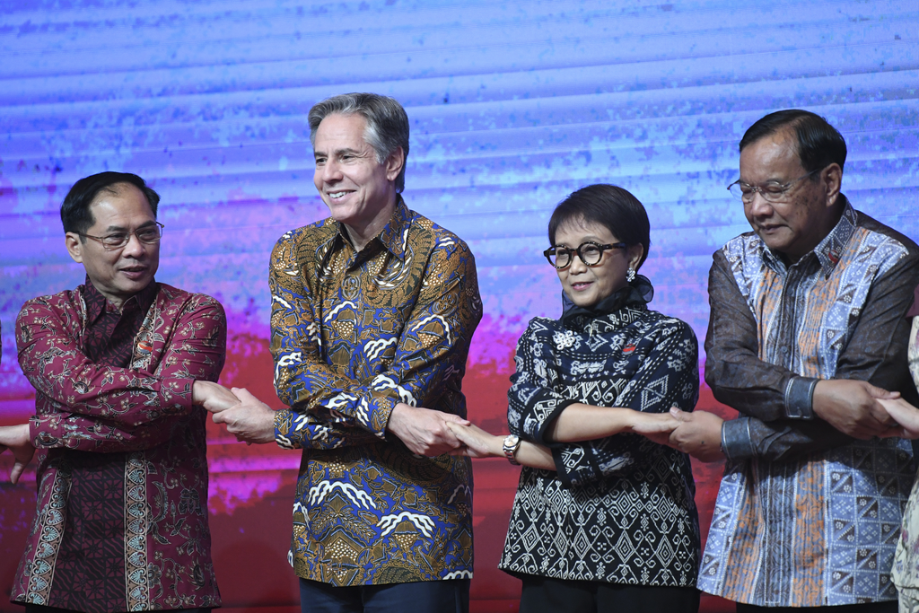

The Minister for Foreign Affairs of Indonesia has called on the United States to join in maintaining peace, stability, and prosperity in the Indo-Pacific region at the ASEAN-US Post-Ministerial Conference with the US Secretary of State (14/7) (Photo: Ministry of Foreign Affairs of Indonesia).

